**Settings for your insulin (DIA and time-to-peak)**

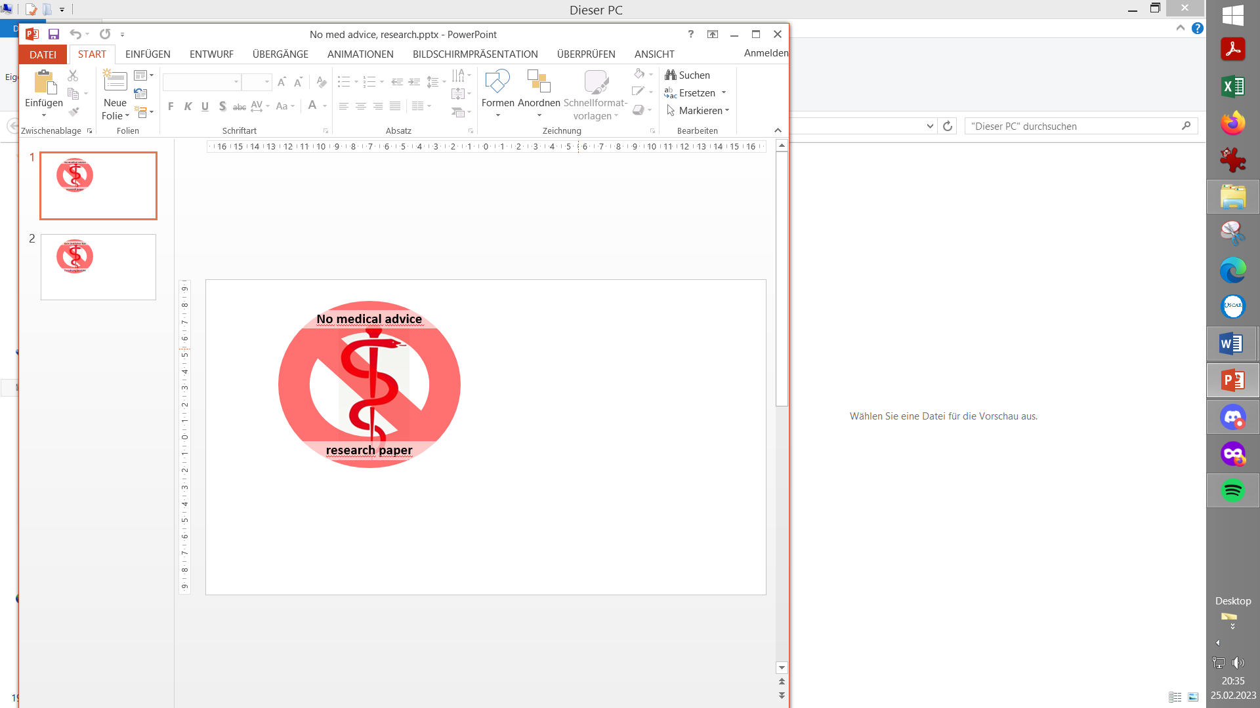

Contribution to the discussion among DIY loopers

The author assumes no liability B/ V.2.3 Mar’24

1. Setting insulin related parameters

1.1 Mathematical model used

1.2 Time-to-peak and DIA

1. 1.2.1 Insulin choice matters for profile ISF, IC
2. 1.2.2 Duration of insulin action
3. 1.2.3 Quantitative effects of changing DIA

2. Other factors of potential relevance

2.1 Age (of the diabetic)

2.2 Dose

2.3 Scatter (imprecision)

3. Mixes of two insulins

4. U200 insulin

5. Complementary utilization of insulins with super fast bio-availability

5.1 i.v. insulin utilization

5.2 Inhaled insulin (Afrezza)

Before doing any other tuning, make sure you are on the insulin you really want to be on, and have reasonably set the insulin-related parameters for your looping system.

In case you are just starting to loop and need to “household” with your time, all you need from this paper should be just two messages:

* Select your insulin in AAPS configuration, and refer to the data given in section 1.2.2 regarding DIA. To set it on 7 h is a fair guess for a start, if you are uncertain.
* You probably heard that Lyumjev or Fiasp are in principle *) best for looping.

*) from an activity kinetics standpoint. References: figure S2 in [https://github.com/bernie4375/HCL-Meal-Mgt.-ISF-and-IC-settings/blob/FCL-w/autoISF/**The**%20**Artificia**l%20**Pancreas**%20**and**%20**Meal**%20**Control**.pdf](https://github.com/bernie4375/HCL-Meal-Mgt.-ISF-and-IC-settings/blob/FCL-w/autoISF/The%20Artificial%20Pancreas%20and%20Meal%20Control.pdf), and also [https://github.com/bernie4375/FCL-potential-autoISF-research-/blob/FCL-book-autoISF/**Case**%20**Study**%201.2_**Insulins**%20for%20FCL_V2.1.pdf](https://github.com/bernie4375/FCL-potential-autoISF-research-/blob/FCL-book-autoISF/Case%20Study%201.2_Insulins%20for%20FCL_V2.1.pdf) .

In section 1.2.1 it is explained why it is a good idea to switch at the start of your looping journey, rather than at some later point.

Changes between insulins with similar time-to-peak, like Fiasp -> Lyumjev, will be easier, and will not require much of an adjustment as in the example given in section 1.2.1.

But of course you can switch at any later time, as well. Many prefer actually to start looping with a less reactive insulin. This enhances safety in the initial months of getting to know, and tuning, the loop. (Same thought is behind the Objectives in AAPS that give access to SMBs only after a couple of other steps).

Also, struggling with too many occlusions (and pain) can make it difficult to switch to one of the fastest insulins.

1. **Setting insulin related parameters**

Besides time-(minutes) to-peak activity, also the duration of insulin action (DIA, hours) that you select in your profile strongly influences how the loop calculates the activity from insulin, as it unfolds in every 5-minute segment that your loop analyzes.

1.1 Mathematical model used

Especially what should be selected as duration of insulin action ( DIA ) is very strongly influenced by the model used to figure out active insulin two, three, and more hours after administration. Misunderstandings about this is often a source for disputes between loopers and their treating physicians.

All insulin administrations (bigger and minor) add up to a insulin activity pattern. In the case of looping, with user boli, basal insulin, TBR modifications and SMBs given at various times, with overlapping DIAs, this can be quite complex.

In AAPS you can see insulin activity in your main screen as an extra thin yellow curve. Together with carb absorption is “explains” most of what you see in your glucose curve.

This **insulin activity pattern is an extremely important basis for each of your loop’s decisions.** Having the wrong settings would give your semi-automated insulin management a permanent drift towards over- or towards under-corrections.

The loop system can still counter-regulate, but – if you burden your’s with wrong DIA or time-to-peak settings in your profile – this would “use up” some of it’s (limited) capacity to regulate for you.

*Example: After heavy dinner, a DIA set too short “tells your loop” that active insulin is practically gone after time X. The loop takes that info for granted, and if it sees some insulin needed at that time X (and be it only for your profile basal need - as you also communicate to the loop, you need to remain stable -), then, at night-time, the loop will give you more insulin than you really need.*

*Therefore, before you tune your ISF differently, make sure to have a look at your DIA setting.*

Please understand (and see to it, that your treating professionals understand) that models can differ strongly:

* DIY looping systems use the – less common – exponential decay model.
* Medtronic uses non-linear capped curves (as in handbook to their pumps)
* Doctors / diabetes educators mostly have a rough linear model in mind
* xDrip uses a bilinear math (“with kinks”) to model insulin activity (Caution: This info might be outdated)

All models are working „good enough“ for their (main) intended applications. But, as explained above, it is worth the effort to use an exact modelling of insulin activity for a loop, so it can perform optimally.

As pointed out already in the section 1 headline, and further explained below, the mathematical model of insulin activity over time anchors on time-to-peak (minutes) and on DIA (hours) in characteristic ways. This is quantitatively shown for exponential decay models in section 1.2.3-

In AAPS, the insulin tab shows two curves: The **pink** one starts at 1.0 (100%) and goes down to 0 (0%) when the DIA is over. It shows how much of the total activity (the capacity to lower bg) is left, at any time. So, it is like the iob number we always have in our AAPS home screen. The problem with that, as with the pink curve, is that it may give you a false impression regarding how much “power” there actually is, now, as you need it. That is where the other curve (and on your AAPS home screen, the related thin yellow insulin activity curve) come in: The **blue** one shows how the activity goes: Practically nothing (!) for a bunch of minutes, then rapidly going high, and then slowly fading out out over the DIA period (with a maximum at time-to-peak). For its calculations, AAPS adds these blue curves up for all boli, SMBs and TBRs $≠$ profile basal!

* 1. Time-to-peak activity and DIA for various insulins

Principally, there are „correct“ settings specific for each insulin type, notably regarding time-to-peak activity. This is pre-programmed in the insulin choices for AAPS, for instance.

Regarding the DIA to set, there is more uncertainty. The following mostly cites or summarizes finings published by David Burren.

1.2.1 Insulin choice matters for profile ISF, IC

The following chart is *the inverse* of the pink curve in the AAPS insulin tab: *Not insulin still there to be used*, but Insulin used up, going from 0% towards 100% in the 9 h DIA, for Humalog with 75 minutes, and for Lyumjev with 45 minutes time-to-peak.

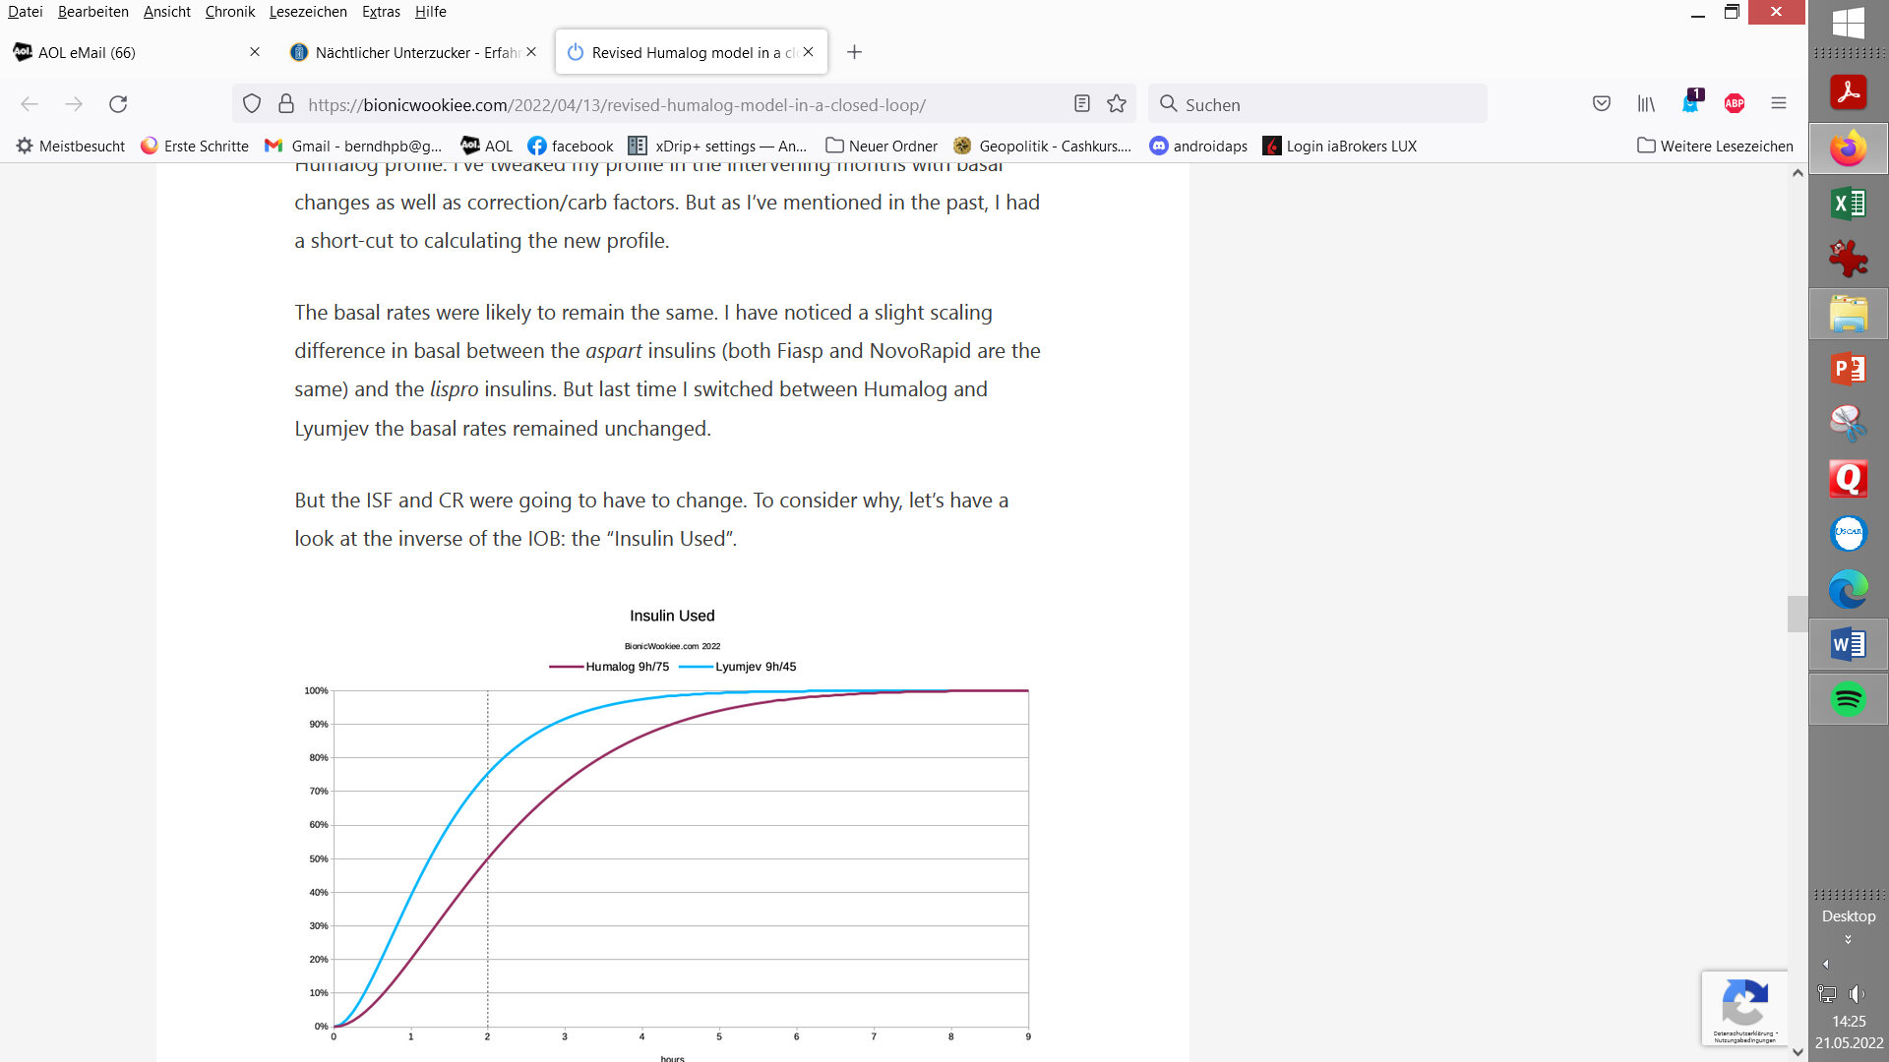

From a simplistic point of view, you can see that at the two-hour mark, more of the Lyumjev (75.5%) should have had effect than the Humalog (50.2%).

So when we’re calculating *how much insulin to give for a correction*, we should tell it to give more Humalog up-front to get the same result after 2 hours.

The system will of course be tracking the IOB and forecasting the BG curves for hours into the future, so we do have some safety built in regarding the extra insulin.

When going from Humalog to using Lyumjev, this must have some consequences for the Insulin Sensitivity Factor (ISF) to use in the profile. If, for example, you had 1.8 mmol(l/U for Humalog, you should expect a “good ISF for going with Lyumjev” in the area of 2.7 mmol/l/U. According to the curves shown above (at dotted 2 hr line) a factor 75.5/50.2 applied yields the same amount of insulin for a correction.

Likewise, the Carb Ratio (IC) may deserve an adjustment when switching insulins.

* The IC could be adjusted by the same factor, for instance it might go from 7.7 g/U (Humalog) to 11.6 g/U (Lyumjev).

For a meal of 60 g, 7.8 U (=60/7.7 g/U) Humalog would have contributed 3.9 U (=50.2%*7.8 U); likewise, 5.2 U (=60g/11.6 g/U) would have contributed 3.9 U (=75.5%*5.2 U)

* For meals bigger than about 60 g you should observe that, while your insulin bolus has good activity, only a limited number of carbs can get digested (30 g/h seems the limit for most). Refer to the paper on IC determination (section “Determination at meal times”) in: https://github.com/bernie4375/HCL-Meal-Mgt.-ISF-and-IC-settings/tree/FCL-w/autoISF

The given example showed that switching to a “faster” insulin can have relevant consequences for your key profile parameters.

David Burren also reports that between the two rather extreme insulin choices he tested, the total amounts of insulin (TDD) did not significantly differ ( - as we would expect: The same amounts just gets delivered slower, even at same selected DIA, with Humalog).

**But while the TDD has** not **changed, the instantaneous insulin levels** have**.**  
When the system is fighting post-meal “highs” the IOB will be noticeably lower with Lyumjev.

Although the average overall level remains similar, this might have some implications for the concept of [hyper-insulinaemia](https://bionicwookiee.com/2022/03/19/hyperinsulinaemia/). This may be a subtle advantage of faster insulins.

1.2.2 Duration of insulin action

The following focusses on the more uncertain topic of which duration of insulin action (DIA) to use. It is largely relies on, and quotes, results from several thorough investigations done by David Burren: (https://bionicwookiee.com)

The numbers he ended up preferring are:

|  |  |  |
| --- | --- | --- |
| **Insulin** | **Peak** | **Duration (DIA)** |
| Humalog | 75 minutes “Rapid-Acting Oref” | 7 hours *)= |
| NovoRapid | 75 minutes “Rapid-Acting Oref” | 9 hours |
| Fiasp | 55 minutes “Ultra-Rapid Oref” | 9 hours |

*) Later investigations <https://bionicwookiee.com/2022/04/13/revised-humalog-model-in-a-closed-loop/> led to suggesting 9 hours DIA also for Humalog

The default constraints in AAPS have the duration limited to 7 hours, so he had to make some local changes to the limits. It’s also possible if you set your “patient type” to “Pregnant”, but if so you need to carefully check all the affected safety limits ([listed in the AAPS documentation](https://androidaps.readthedocs.io/en/latest/Usage/Open-APS-features.html#overview-of-hard-coded-limits)). This may change in a future update to AndroidAPS.

For Lyumjev (45 minutes; Lyumjec Oref), there is not a big difference between a 7 and a 9 h DIA:

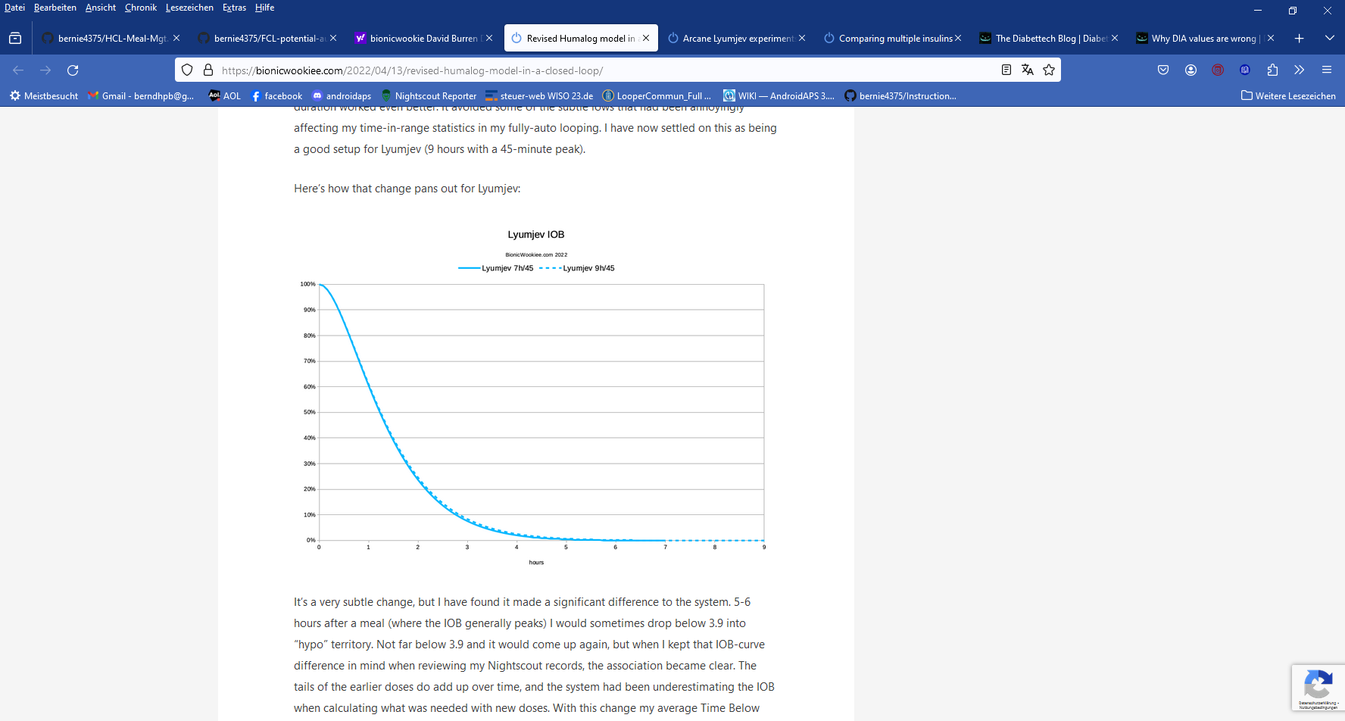

However, David Burren (<https://bionicwookiee.com/2022/04/13/revised-humalog-model-in-a-closed-loop/> ) reports that, despite it’s a very subtle change, he has found it can make a significant difference 5-6 hours after a meal, when …the tails of the earlier doses do add up, and the system had been underestimating the IOB when calculating (using the shorter DIA) what was needed with new doses. With changing to a longer DIA, his average Time Below Range has reduced. (Comment: This is interesting for “fine-tuning extremists” but probably only a formal gain of little clinical significance, assuming the bg curve just swinging a bit more often, or longer, by a few mg/dl below the 70 mg/dl cut-off, that defines “below range”. Judge from your own data, when/if fine tuning.)

On the DIA topic for various insulins see also: <https://www.diabettech.com/insulin/why-we-are-regularly-wrong-in-the-duration-of-insulin-action-dia-times-we-use-and-why-it-matters/>

1.2.3 Quantitative effects of changing DIA

Any given insulin dose comes with a defined total capacity for a certain bg lowering effect. How strong or weak this unfolds over a couple of hours can be mathematically modelled. In oref(1) systems, time-to-peak and DIA completely define this curve.

We can look on effects of increasing the set DIA in terms of how insulin activity would differ at any moment after administering a dose.

The next example given (chart below) does that for going from a 5 h DIA, a 6 h DIA or a 7 h DIA towards 9 h for Lyumjev

We see the peak going lower, and the tail activity higher when DIA is increased:

**LYUMJEV** peak @45m max effect on “tail” at ~ 3.5 h (220 minutes)

DIA 5→9h | **minus 5.5 % plus 2.5%**

DIA 5→6h | minus 2,7 % plus 1.3%

DIA 6→9h | **minus 2.8 % plus 1.2%**

DIA 6→7h | minus 1,4 % plus 0.6%

DIA 7→9h| - **minus 1.4 % plus 0.6%**

So, the „tail“ effects differ by less than 3 percent (of peak activity=100%) in the later stages of DIA:

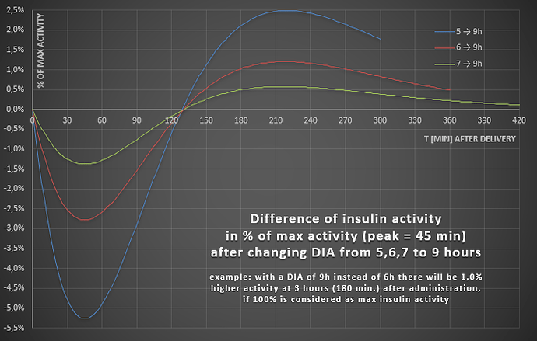

While 3 % sounds low, the significance of the problem should not be underestimated:

* For our Lyumjev case, note that the quoted 3% result is *3% of maximal* *activity.*

*Example: Activity at 180 minutes is about 0.0010 compared to 0.0080 at peak (blue curve in AAPS INS tab). 2.5% of 0.0080 would be 0.0002. BUT: 0.0012 is 20 % more than 0.0010, so* **REALLY the difference in activity at 180 minutes can be up to 20%** . *Still, after a bolus of 8 units (and/or SMBs that reach that iob level) for a typical meal, the max. difference from 5 -> 9 hour DIA would roughly be, whether 1.0 U or 1.2 U are active iob left at 180 minutes.* That ***difference ( + 0.2 U)*** should be within the loop’s regulating capacity from reducing basal.

However,it becomes much bigger for users of other insulins (with longer time-to-peak):

* The delta **effects get much bigger with insulins that have a longer time-to-peak**

Some quantitative data for other insulins are as follows:

**FIASP** (peak=60m) min/**max** differences

DIA **5→9h** | 6→9h | 7→9h: -10,1 **/ +6,8%** | -5,6 / +3,0% | -2,9 / +1,4%

**NOVORAPID** (peak=75m) min/**max** differences

DIA 5→9h | 6→9h | 7→9h: -15,4 **/ +14,1%** | -9,1 / +7,0% | -4,8 / +3,0%

*Above example applied to Novorapid **):* The effect would be up to +14.1% *of max (!)* => 2.1 U instead 1 U at 180 minutes. A ***difference of + 1.2 U*** results here, if DIA is set at 5, not at 9 h, so **REALLY** it could go **up to + 120%** !)

More see: szantos, de.loopercommunity.org May 2022 <https://de.loopercommunity.org/t/naechtlicher-unterzucker/10626>

**) 2,5% → + 0.2 U ergo 14.1% → +1,1 U stimmt insofern nicht ganz genau, als man beim Novorapid Case auch die Novorapid Peak-Höhe zugrunde legen müsste (die ich aber nicht greifbar habe). Wenn diese von Haus aus 20% niedriger nur kommt, hätten wir ca + 0,9U, also weiterhin etwa eine Verdoppelung … die wir mit unserer Wahl eines längerem DIA unserem Loop sagen könnten, damit er entsprechend weniger zu-schiesst … ergo weniger Hypogefahr hinten heraus …

1. **Other factors of potential relevance** *Source:*[szantos](https://de.loopercommunity.org/u/szantos)

The findings reported below can give you hints in which direction to look if you attempt to fine-tune your settings further, from the standard suggestion what should be suitable for your insulin (section 1.2.2.).

2.1 Age (of the diabetic)

[ema.europa.eu](https://www.ema.europa.eu/en/documents/variation-report/novorapid-h-c-258-p46-0044-epar-assessment-report_en.pdf)

[**novorapid-h-c-258-p46-0044-epar-assessment-report_en.pdf 3**](https://www.ema.europa.eu/en/documents/variation-report/novorapid-h-c-258-p46-0044-epar-assessment-report_en.pdf)

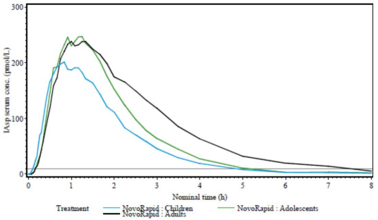

* 1. Dose

<https://journals.sagepub.com/doi/10.1177/1932296813514319>

[[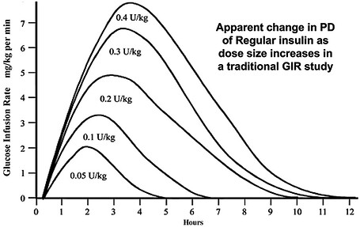](https://de.loopercommunity.org/uploads/default/original/2X/0/0aa77fcb95d147dbf58720ec484a1e49f54a532f.jpeg)](https://de.loopercommunity.org/uploads/default/original/2X/0/0aa77fcb95d147dbf58720ec484a1e49f54a532f.jpeg" \o "image)

[image1000×632 78.4 KB](https://de.loopercommunity.org/uploads/default/original/2X/0/0aa77fcb95d147dbf58720ec484a1e49f54a532f.jpeg" \o "image)

* 1. Scatter (imprecision)

Individual deviations from standard suggestions could also be justified by the fact, that all studies that underly the previously reported suggestions, come with very significant person-to-person scatter.

All lines in the charts, as above shown from studies, are averaged data. (Some studies are indicating the very significant scatter seen, as well).

[https://www.researchgate.net/figure/Pharmacodynamic-profiles-Insulin-action-as-expressed-as-GIR-required-to-maintain_fig1_41424712 2](https://www.researchgate.net/figure/Pharmacodynamic-profiles-Insulin-action-as-expressed-as-GIR-required-to-maintain_fig1_41424712)

1. **Mixes of two insulins**

The author did for some time successfully use a 50/50 mix of Fiasp and Novorapid, applying the time-to-peak for Fiasp, and longest of the two DIA, as was suggested at the time, for these insulins.

For a more thorough discussion see <https://bionicwookiee.com/2022/03/02/mixing-insulins-theory-and-practice/>

and also: <https://bionicwookiee.com/2023/06/03/arcane-lyumjev-experiments/>

1. **U200 insulins**

Using up-concentrated insulins, e.g. in a U200 form, is sometimes chosen by loopers

* to reduce needed daily insulin volumes and get more time from 1 pump filling (pod)
* to reduce volume per injection for getting better tolerance regarding occlusions or pain

There are no relevant effects on insulin parameters like DIA and time-to-peak.

However, dilution or up-concentration factors are highly relevant for setting profile factors like ISF and IC, and also for some important safety settings like max iob for instance.

Refer to special discussions on that topic, e.g. here re. U200 Lyumjev <https://www.diabettech.com/lyumjev/living-with-lyumjev-almost-a-year-in-review/> :

and also: <https://bionicwookiee.com/2023/06/03/arcane-lyumjev-experiments/>

1. **Complementary utilization of insulins with super fast bio-availability**

A core problem coming with any sub-cutaneous insulin provision (via sub-cutaneous injections, or via insulin pumps) is that time-to-peak activity can be rather long. Two faster ways to get insulin into blood are: direct venous injection, and via inhaling insulin into the lungs.

**5.1 Using i.v. insulin**

The “beauty” of using intra-venous insulin at around meal starts would stem from its much faster bio-availability, and also much shorter DIA

Case report: I do a basically unknown amount of insulin intravenously, let it be between 4 and 8 units (well below the size that my meal bolus would be). It really doesn’t matter anyhow. What it does ,it brings me down to target within 30-40min. I record something like 4-6 units (so my loop doesn't want to get excessive insulin). Essentially, this prevents getting insulin longer than it actually has an effect (mine is gone from the system after 35min). To eliminate the false “activity tail” assigned also to the i.v. potion of insulin on bord, you can delete the i.v. insulin amount from the system *after it has done it's job* (not good for statistics/history data, but right, going forward without the DIA tail = letting your loop know the real iob).

It's an edge use (experimental) case . (source: Robert, discord FCL/iaAPS w autoISF, March 2024):

**Please observe that this is not a recommendation to experiment with i.v. insulin** unless in a medically supervised research context.

i.v. insulin is usually restriced to the surgical and intensive care hospital environments!

* 1. **Inhaled insulin (Afrezza)**

Afrezza is an inhaleable very fast (and also short) acting insulin which some find useful to correct high glucose levels.

Pro: An insulin inhalation addresses the need for a fast correction of a bg high, and even without the hours-long tail of effects.

Cons: 1) Afrezza spray is hard to dose. 2) Also it is not advisable to enter data into loop because the kinetics of this insulin are very different. => The short term problem is solved, but there are consequences in the upcoming hours from skewed calculations and eventually also (via Autotune-driven basal and factor adjustments) for the next days. ((Could partially be resolved if insulin unit equivalents coming from Afrezza are entered at bolus time, and then erased, as soon as it’s activity is over)). 3) Primary approach should be to avoid high bg by finding a proper meal management strategy (pre-bolus time, EatingSoonTT).

Still Afrezza can be a reasonable remedy in times. Solving the problem at hand as best as we can, even if it makes the time afterwards a bit more complicated, is the name of the game. We and our loop do this all the time, for instance by giving more upfront insulin, then reducing basal (zero-temping).

(from slide 38 of: Meal Mgt. Basics, <https://github.com/bernie4375/HCL-Meal-Mgt.-ISF-and-IC-settings> )